Computer Networks

Lab 04

Hamza Shahid
20P-0117
BSSE-5A

Task 01:

- First you need to drag 2 laptops, 1 PC and a router.
- Configure static IP address pf server.
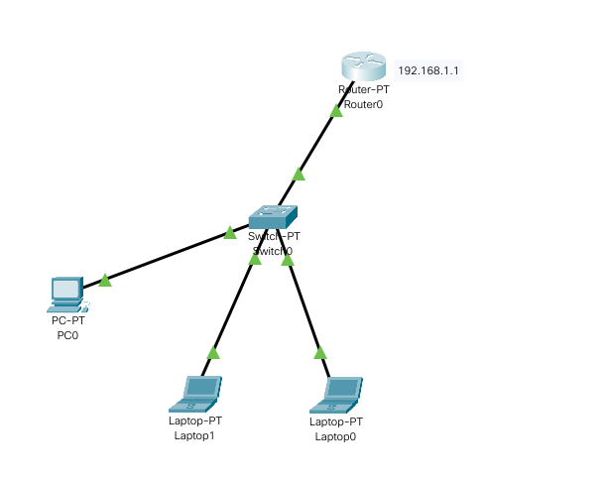
- Now configure DHCP service on server by following steps:
  - Click on server and click on CLI
  - ip dhcp pool name_of_dhcp_pool
  - network network_ip subnet_mask
  - default-network network_ip
  - default-router router_ip
  - dns-server default_gateway_of_router
  - ex
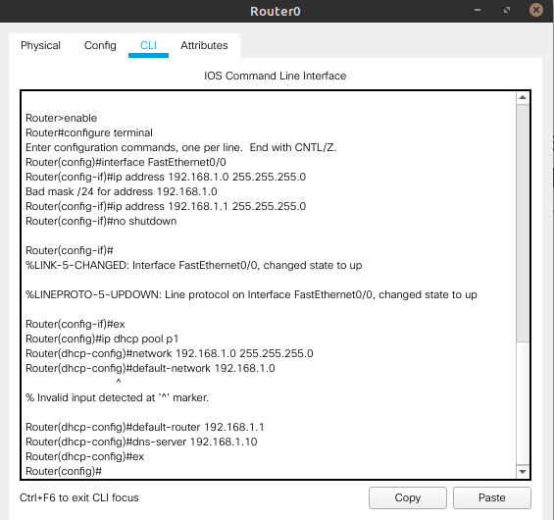
- Now click on each PC / laptop.
- And enable DHCP instead of Static
- And all addresses will be assigned by router.
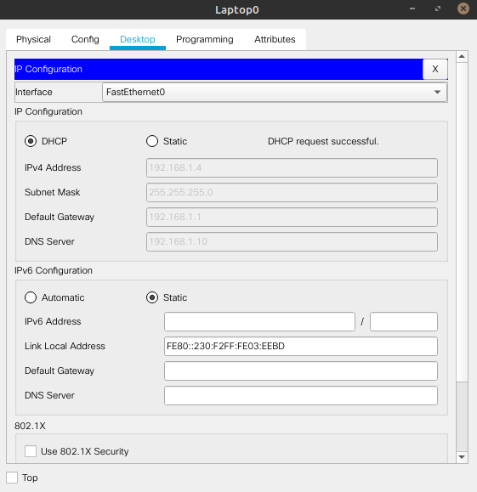

Task 02:
- Set up the network we made above.
- This time just connect the router with the server.
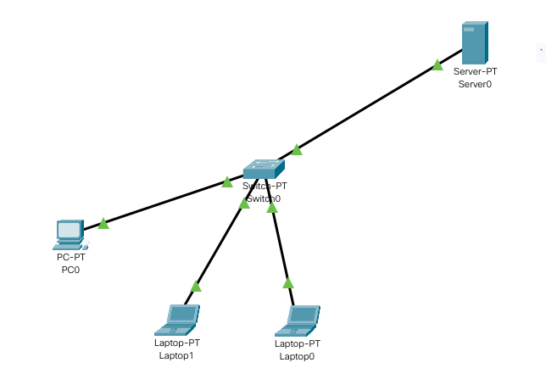
- Now set up DHCP pool by clicking on server and then click on services tab.
- Then choose DHCP, click on add and fill all the info required like pool name, gateway address and DNS server etc.
- Then click on save. The pool will be listed below.
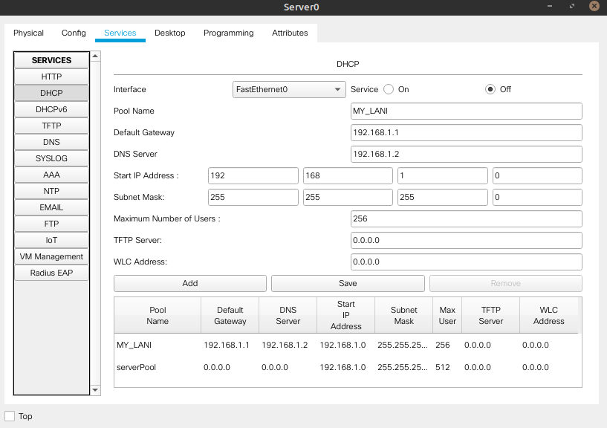

- Then click on Desktop and assign IP address to DHCP.
- Now click on each PC and click on DHCP instead of server.
- All the addresses will be assigned to them by server.
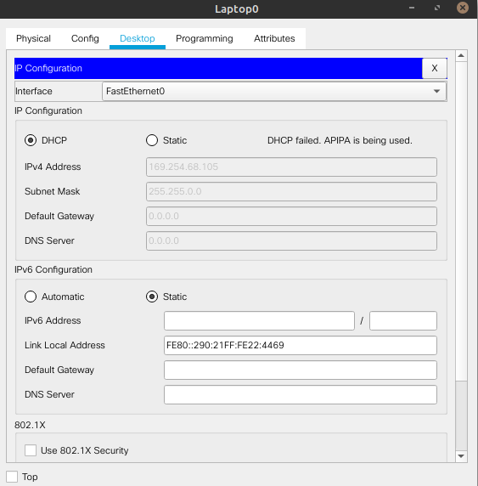
Final Task:
- Create the following topology by dragging them to screen.
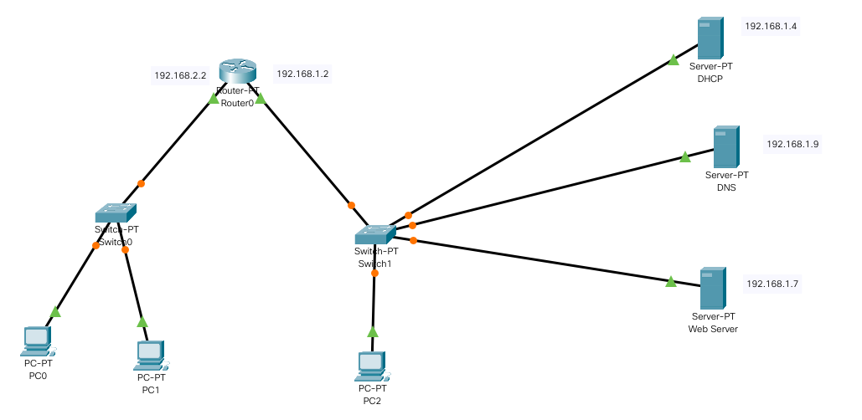
- Click on router and assign IP to both ports.
- Create pool only for the left side ( router with the two PCs ).
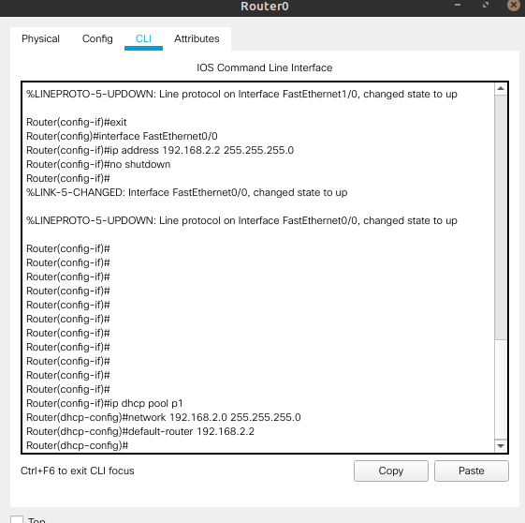

DHCP server:
- Click on DHCP. And assign IP, subnet, gateway and DNS server address.

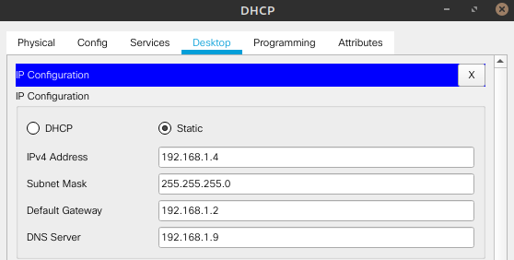
- Now click on Services then on DHCP.
- Create pool for the server with the one PC.
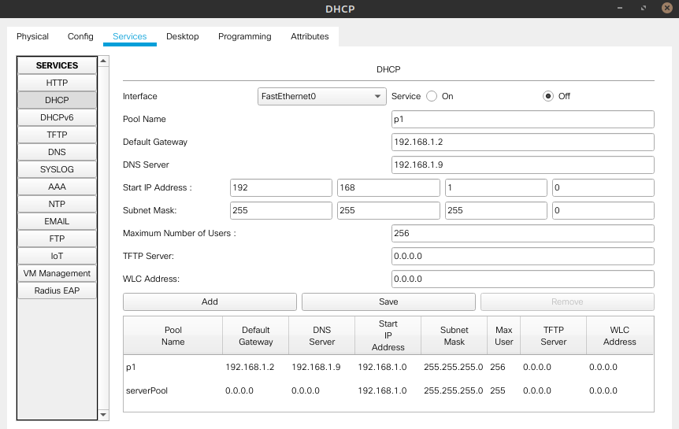
DNS server:
- Now click on DNS server, then click on Services and then click on DNS.
- Add two DNS with the URL and IP of rest of the two servers.

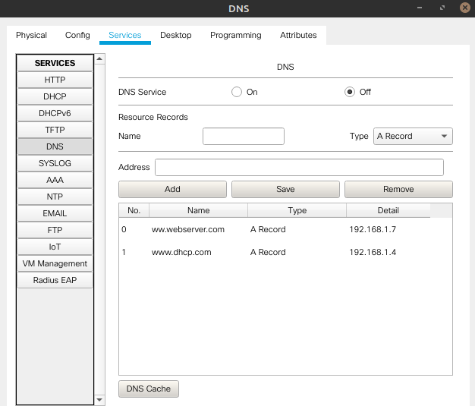

Web server:
- Now click on server named “Web Server”.
- And assign IP, subnet, gateway and DNS server address.
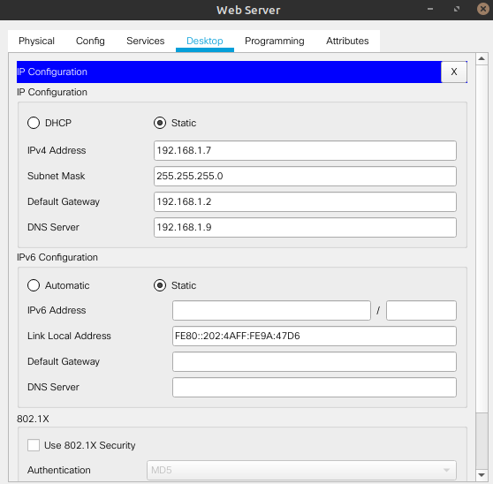
- You can also edit the html page by clicking on HTTP.
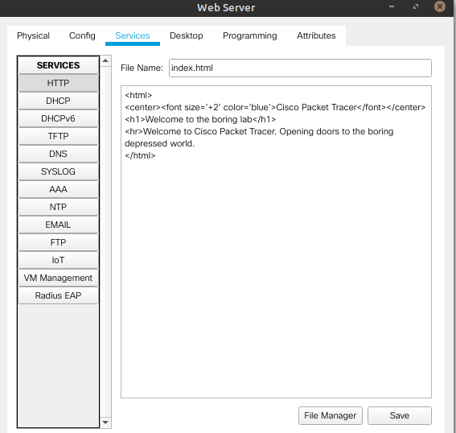

- Now go to every PC and enable DHCP.
- First created pool will assign the PC addresses by router.
- Second one pool will assign the addresses to the two PCS connected to server.

